# GitHub Link: https://github.com/thetalhamirza/pflabs/tree/main/Lab%208

# Task 1:

Code:

#include <stdio.h>

int main() {

int array[3][3];

for (int row = 0; row < 3; row++) {

for (int col = 0; col < 3; col++) {

printf("Enter score for participant %d, activity %d: ", row+1, col+1);

scanf("%d", &array[row][col]);

}

printf("\n");

}

int sumAct = 0, sumPart = 0;

for (int part = 0; part < 3; part++) {

sumPart = 0;

for (int act = 0; act < 3; act++) {

sumPart += array[part][act];

}

printf("Sum for participant %d: %d", part+1, sumPart);

printf("\n");

}

printf("\n");

for (int act = 0; act < 3; act++) {

sumAct = 0;

for (int part = 0; part < 3; part++) {

sumAct += array[part][act];

}

printf("Sum for activity %d: %d", act+1, sumAct);

printf("\n");

}

return 0;

}

Screenshots:

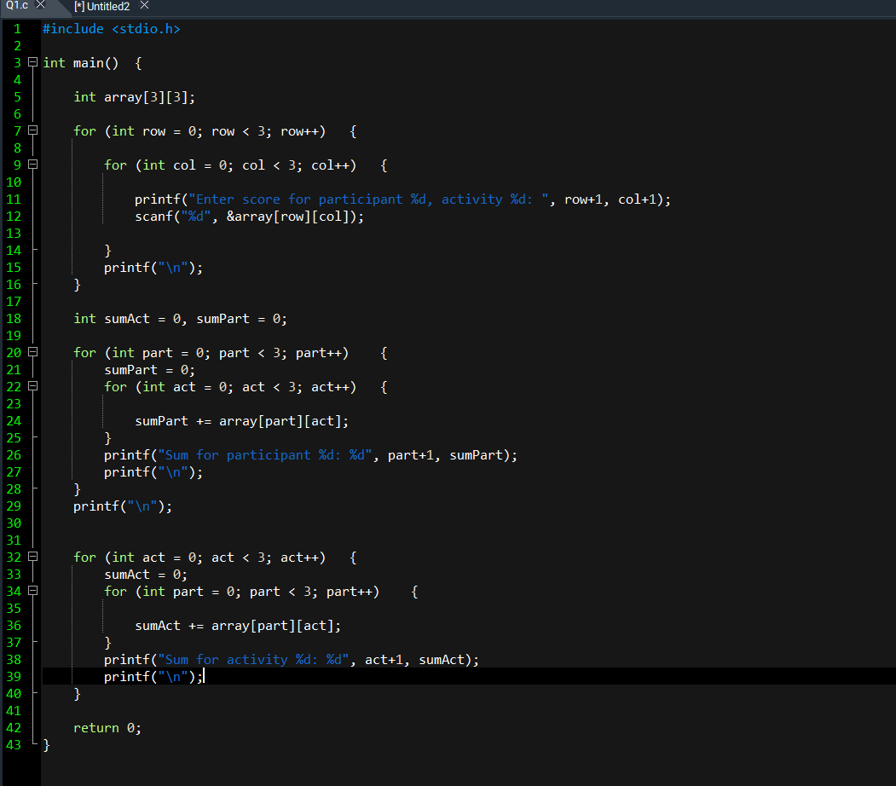

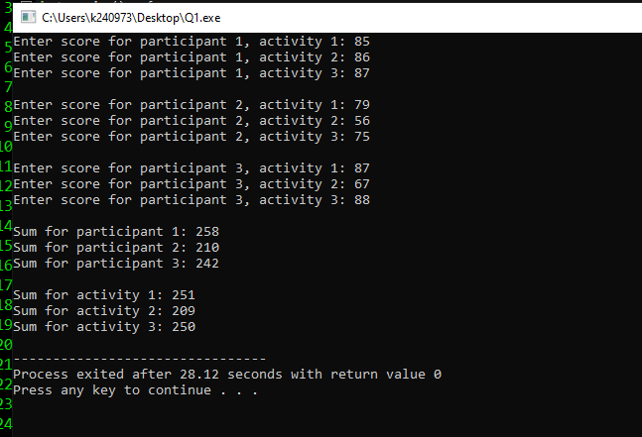

# Task 2:

Code: #include <stdio.h>

int main() {

int array[4][4];

for (int student = 0; student < 4; student++) {

for (int subject = 0; subject < 4; subject++) {

printf("Enter grade for student %d, subject %d: ", student+1, subject+1);

scanf("%d", &array[student][subject]);

}

printf("\n");

}

for (int student = 0; student < 4; student++) {

for (int subject = 0; subject < 4; subject++) {

if (array[student][subject] < 0) {

array[student][subject] = 0;

}

}

}

for (int student = 0; student < 4; student++) {

for (int subject = 0; subject < 4; subject++) {

printf("%d ", array[student][subject]);

}

printf("\n");

}

return 0;

}

Screenshots: 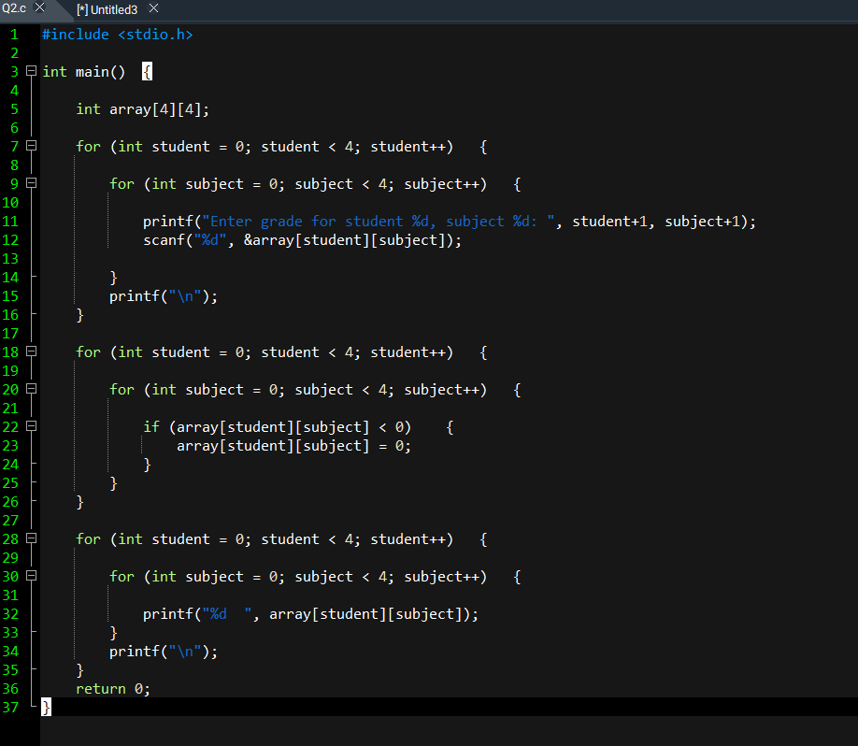

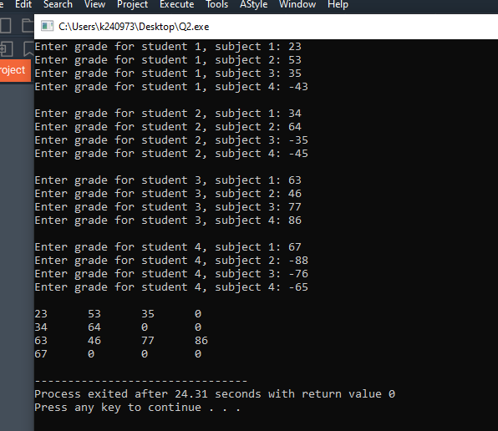

# Task 3:

Code:

#include <stdio.h>

int main() {

int num;

printf("Enter n: ");

scanf("%d", &num);

int value = num;

int iter = 0;

while (value > 0) {

for (int i = 0; i < iter; i++) printf(" ");

for (int j = value; j > 0; j--) {

printf("%d ", j);

}

iter+=1;

value -= 1;

printf("\n");

}

value += 2;

iter-=2;

while (value <= num) {

for (int i = 0; i < iter; i++) printf(" ");

for (int j = value; j > 0; j--) {

printf("%d ", j);

}

value++;

iter--;

printf("\n");

}

return 0;

}

Screenshots: 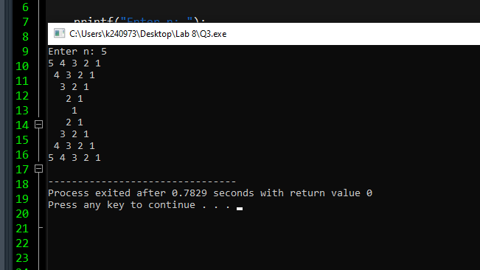

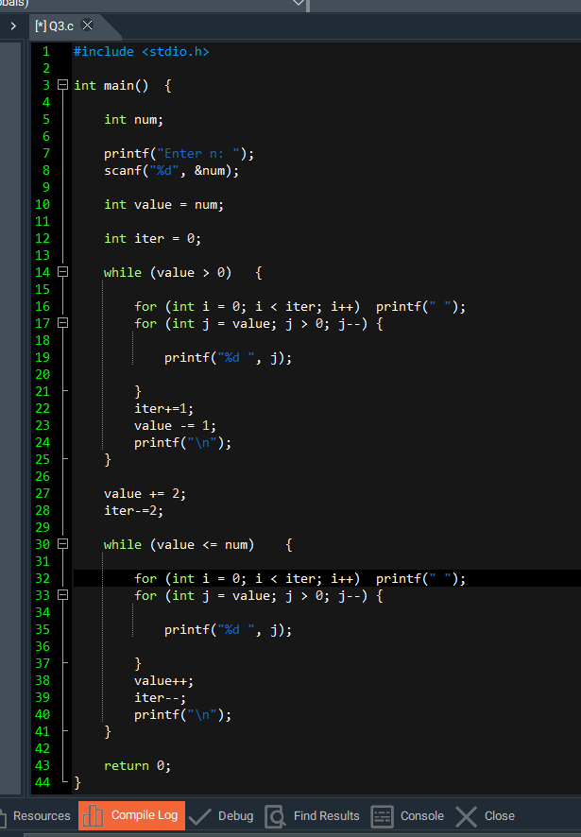

# Task 4:

Code:

#include <stdio.h>

int main() {

int aVert, aHoriz;

int bVert, bHoriz;

printf("Write vertical dimensions for matrix 1: ");

scanf("%d", &aVert);

printf("Write horizontal dimensions for matrix 1: ");

scanf("%d", &aHoriz);

printf("Write vertical dimensions for matrix 2: ");

scanf("%d", &bVert);

printf("Write vertical dimensions for matrix 2: ");

scanf("%d", &bHoriz);

int arrA[aVert][aHoriz];

int arrB[bVert][bHoriz];

for (int i = 0; i < aVert; i++) {

for (int j = 0; j < aHoriz; j++) {

printf("Enter row %d column %d for matrix 1: ", i+1, j+1);

scanf("%d", &arrA[i][j]);

}

}

printf("");

for (int i = 0; i < bVert; i++) {

for (int j = 0; j < bHoriz; j++) {

printf("Enter row %d column %d for matrix 2: ", i+1, j+1);

scanf("%d", &arrB[i][j]);

}

}

int finVert;

int finHoriz;

if (aVert > bVert) {

finVert = aVert;

} else {

finVert = bVert;

}

if (aHoriz > bHoriz) {

finHoriz = aHoriz;

} else {

finHoriz = bHoriz;

}

int finArr[finVert][finHoriz];

for (int i = 0; i < finVert; i++) {

for (int j = 0; j < finHoriz; j++) {

finArr[i][j] = 0;

}

}

for (int i = 0; i < finVert; i++) {

for (int j = 0; j < finHoriz; j++) {

if (arrA[i][j] != '\0' && arrB[i][j] != '\0') {

finArr[i][j] = arrA[i][j] + arrB[i][j];

} else if (arrA[i][j] == '\0') {

finArr[i][j] = arrB[i][j];

} else {

finArr[i][j] = arrA[i][j];

}

}

}

printf("\n\n");

for (int j = 0; j < finHoriz; j++) {

printf(" %d ", finArr[i][j]);

}

printf("\n\n");

}

return 0;

}

Screenshots: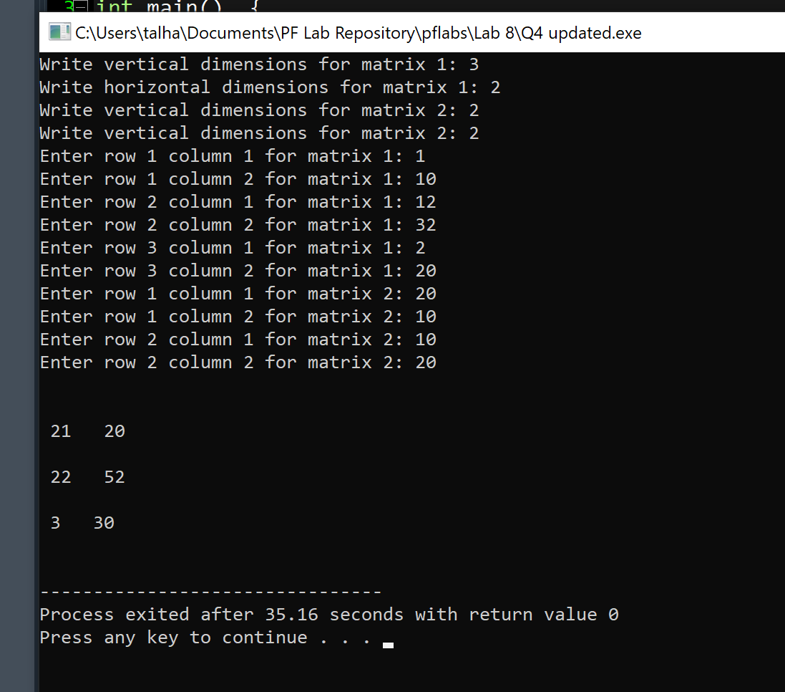

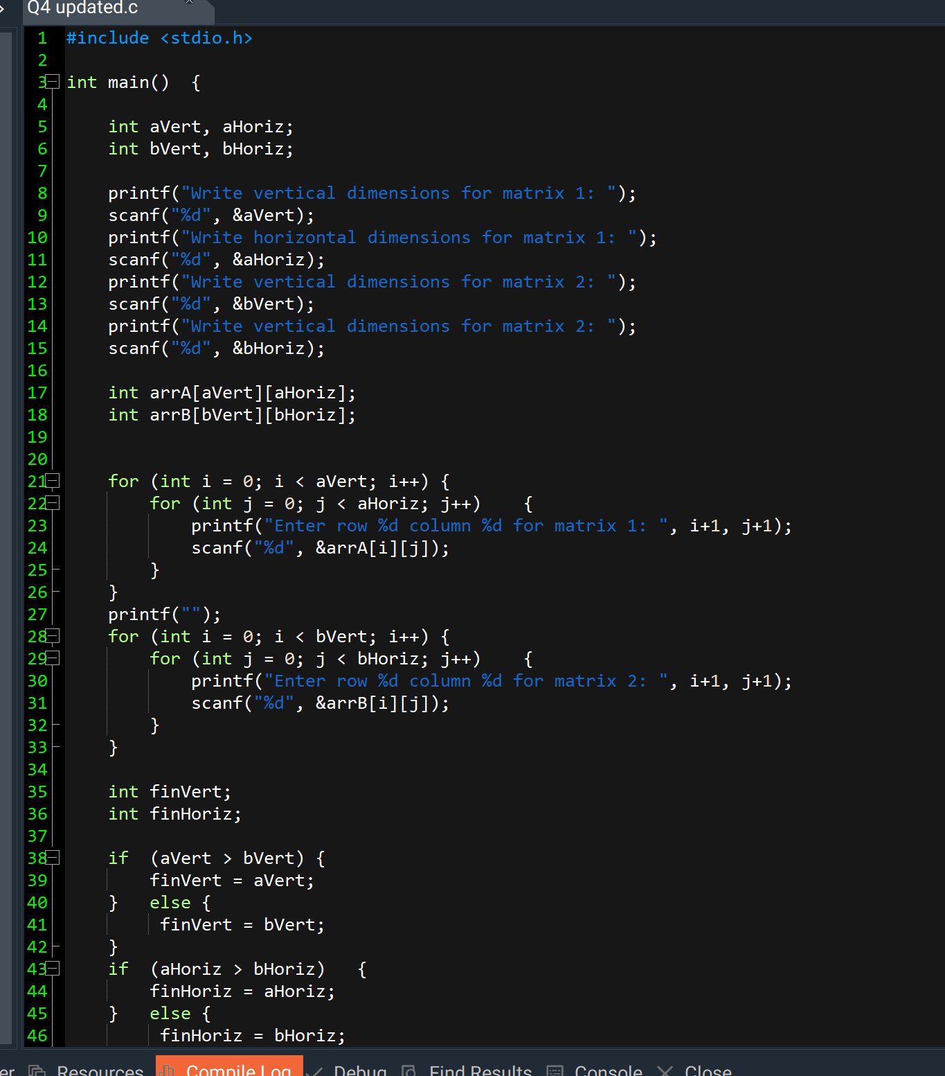

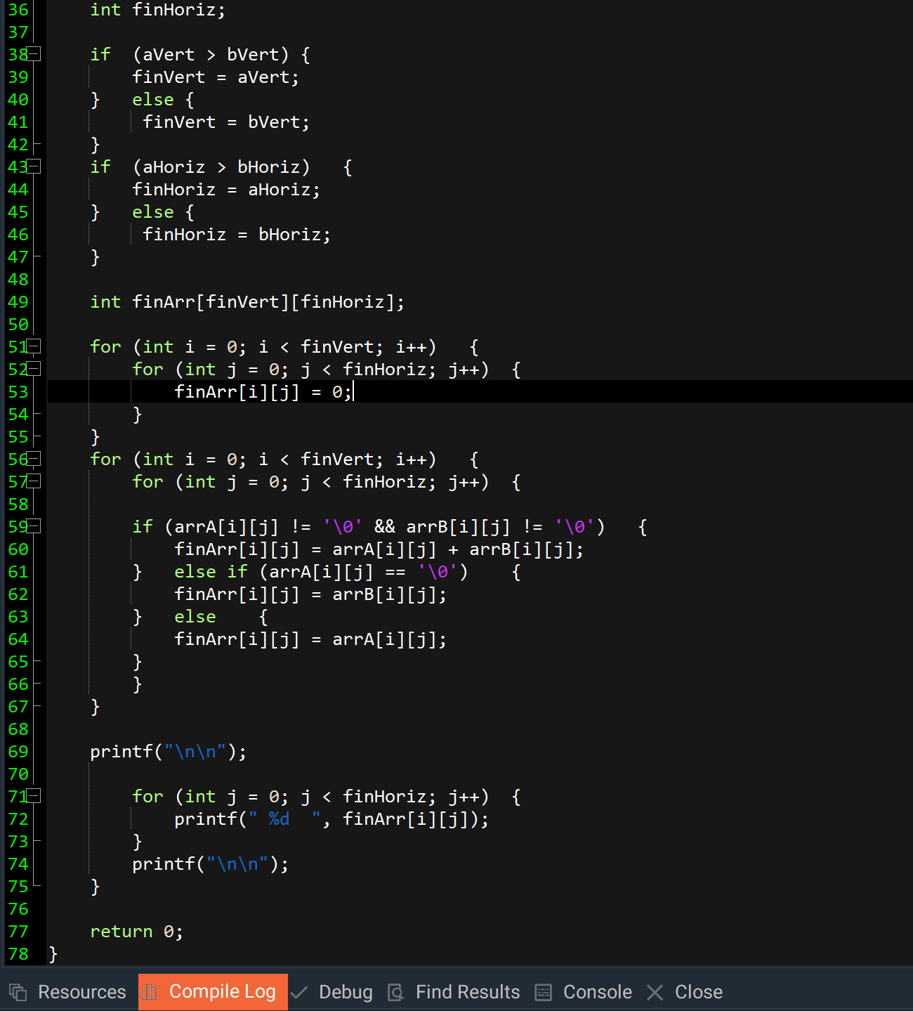

# Task 5:

Code:

#include <stdio.h>

void printArray(int array[4][4]) {

printf("\n");

for (int i = 0; i < 4; i++) {

for (int j = 0; j < 4; j++) {

printf(" %d\t", array[i][j]);

}

printf("\n");

}

}

void sortColumns(int array[4][4]) {

for (int col = 0; col < 4; col++) {

for (int i = 0; i < 3; i++) {

for (int j = i + 1; j < 4; j++) {

if (array[i][col] > array[j][col]) {

int temp = array[i][col];

array[i][col] = array[j][col];

array[j][col] = temp;

}

}

}

}

}

int main() {

int array[4][4];

for (int i = 0; i < 4; i++) {

for (int j = 0; j < 4; j++) {

printf("Enter column %d row %d: ", i + 1, j + 1);

scanf("%d", &array[j][i]);

}

}

printf("\nBefore sorting columns:\n");

printArray(array);

sortColumns(array);

printf("\nAfter sorting columns:\n");

printArray(array);

return 0;

}

Screenshots:

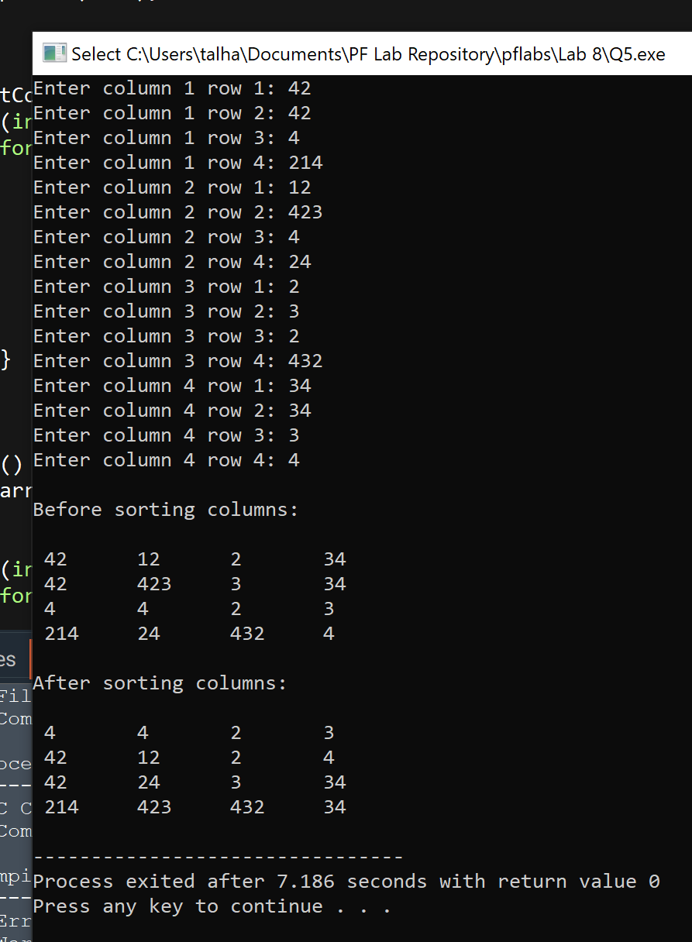

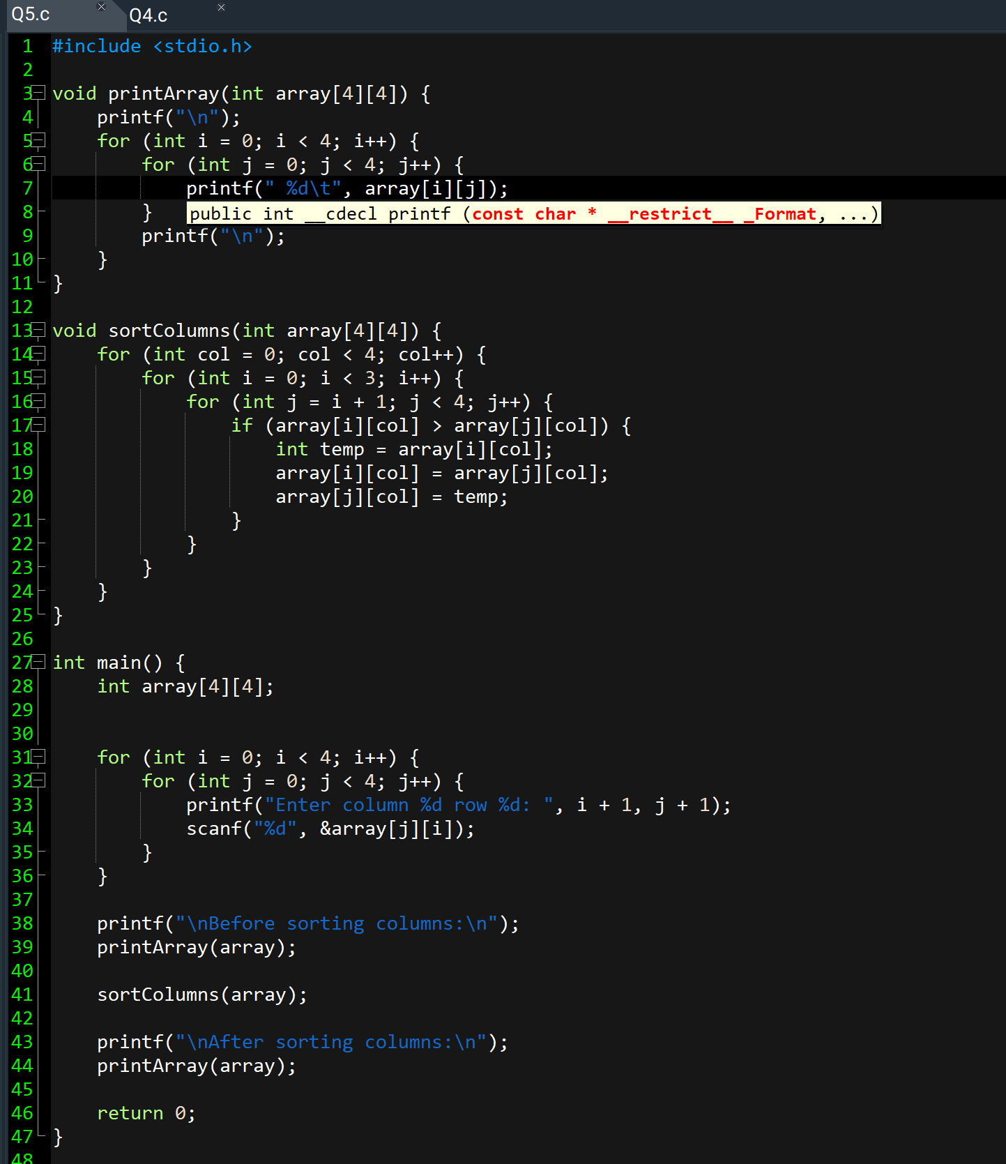

# Task 6:

Code:

#include <stdio.h>

int main() {

int n;

printf("Enter n: ");

scanf("%d", &n);

for (int i = 0; i < n; i++) {

for (int j = 0; j < n; j++) {

if (i == 0 || i == n - 1 || j == 0 || j == n - 1 || i == j || j == n - i - 1) {

printf("* ");

} else {

printf(" ");

}

}

printf("\n");

}

return 0;

}

Screenshots:

